**INTRODUCTION**

Robots are replacing human work force in almost all filed. The benefit of robot based design is that it can be deployed anywhere an it will not be bored or irritated by some repeated or monotonous tasks. It can with stand physical conditions where a normal human fails. Moreover they can be automated to execute some tasks. As AI robots are under development in future robotics is having a wide range of applications. Here in our project we are having a floor cleaning robot that can be controlled wirelessly to clean a room. The robot a demo product that has a rotating cleaning mechanism and a soap dispenser pump to spray soap solution in to the cleaning area. The whole process can be remotely controlled by an ASK remote that is having a reasonably high range of operation. The robot has a tank inbuilt and a lead acid battery is used to power the robot that allows 3 hours back up in a single charging

**BLOCK DIAGRAM**

**TRANSMITTER SECTION**

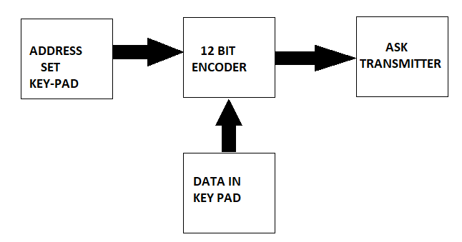

**RECEIVER SECTION WITH ROBOT**

